Public Mental Health Strategy Survey

February 2022

Easy Read version
 | A strategy means a plan of what we will do.
 | The COVID-19 pandemic has changed the way that many of us live, work, see our family and friends, and take part in activities.
 | This means it is important that we make sure that we look after our physical and mental health in future.
 | The Public Health Team at Cambridgeshire County Council and Peterborough City Council would like to hear from people about what they should be doing to help people to have good mental health.
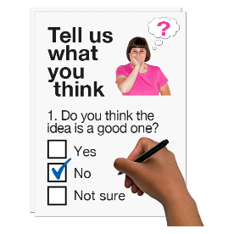 | This survey is to help them develop a Public Mental Health Strategy that will:  - Help stop mental health problems happening or getting worse.  - Promote good mental health for people and communities.
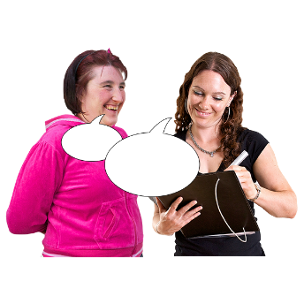 | Please can you give feedback on how your mental health affects  - You.  - Your family.  - Your friends.  - Your work.  - Your community.  You need to think about:  - What works for you.  - What you think could help people in your community.  - What could be done better.
 | Your answers are confidential, but feedback will be included in a report that will be used to write a local Public Health Strategy about Mental Health.
You do not have to give us any personal information.

We will keep your information confidential and safe in line with the Data Protection Act 2018.

 | The closing date for the survey is 28 February 2022.
Please e-mail your reply to:

Clair.Dorans@cambridgeshire.gov.uk
 | Thank you for taking part in this survey.

Information about you

Please can you tell us more about yourself.

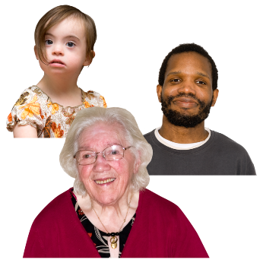 | - How old are you?  Please tick () one box.  Under 18 years  19-25 years  26-35 years  36-50 years  51-70 years  71-85 years  Over 85 years  Prefer not to say
- How would you describe your gender?
Please tick () one box.

Female
Male
Other, please specify
Prefer not to say

- What is your ethnicity?

Please tick () one box.

White
Mixed / Multiple ethnic groups
Asian or Asian British
Black, African, Caribbean or Black British
Gypsy or Irish Traveller
Other, please specify

- What area do you live in?

Please do not give your full address.

Please tick () one box.

Cambridge
Peterborough
South Cambridgeshire
East Cambridgeshire
Huntingdonshire
Fenland

- What is your employment status?

Please tick () one box.

Employed
Self-employed
Unemployed
Student
Retired
Full-time carer
Other, please specify

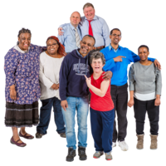 | - What is your marital status?  Please tick () one box.  Single  Married  In a relationship with unmarried partner  Separated  Divorced  Widowed  Other, please specify  Prefer not to say
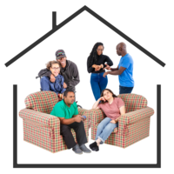 | - Who do you live with?  Please tick () all boxes that apply.  Live alone  With partner  With children  With parents  With grandparents  With friends / housemates  Other, please specify  Prefer not to say

 | Questions about mental health
- Have you been diagnosed with, or do you think you have, a mental health condition?

Please tick () one box.

Yes – I’ve been diagnosed by a doctor
Yes – But I’ve not been diagnosed by a doctor
No
Unsure
Prefer not to say

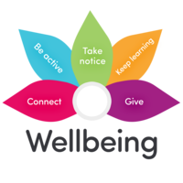 | - How much do the things below help you to say mentally well?  Please tick ()one box for each thing.  Not at all Not sure / neutral A little A lot  Time with friends / family  Online sources of support  Physical activity  Hobbies / learning a new skill  Local face to face sources of support  Mindfulness  Other, please specify below
10) How much do you think the things below stop you or others from being mentally well?

Please tick () one box for each thing.

 | Not at all | Not sure / neutral | A little | A lot
Stress at work / stress at education / unemployment
Problems with family / relationships / friendships
Loneliness / isolation
A lack of community support
Money worries
Physical health worries
Housing or homelessness worries
Social media
Discrimination
Other, please specify below

11) What would you like to see happen in your community to help promote good mental health?

Please tick () all boxes that apply.

Additional social support groups in the community
Additional online resources of support
Exercise / activity groups for those struggling with mental health
Resources for money / employment advice
Local campaigns to raise awareness
Mental health support run by services other than the NHS
Other, please specify below

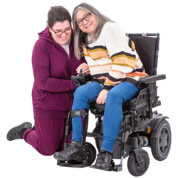 | If you are a carer of anyone with a physical or mental health condition, also please answer the following questions.
- How much would the things below help you to have better mental health?

Please tick () one box for each thing.

 | Not at all | Not sure / neutral | A little | A lot
Additional social support groups for carers in the community
Additional online resources of support
Exercise / activity groups for those struggling with mental health
Resources for money / employment advice
Local campaigns to raise awareness
Practical support with care
Other, please specify below

- What, if anything, would support you to help the person you care for with their mental health?

Please tick () all boxes that apply.

Educational resources about mental health conditions
Information on local support networks / resources for people struggling with their mental health
Local campaigns to raise awareness
Other, please specify below

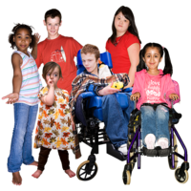 | If you have children, also please answer the following questions.
- Do you think any of your children have poor mental health now?

Please tick () one box only.

Yes
No
Unsure
Prefer not to say

- How much would the things below help your child or children to have better mental health?

Please tick () one box for each thing.

 | Not at all | Not sure / neutral | A little | A lot
Additional social support groups in the community
Additional online resources of support
Additional support available through school
Exercise / activity groups for those struggling with mental health
Local campaigns to raise awareness
Mental health support run by services other than the NHS
Other, please specify below

- What if anything would support you to help your child or children with their mental health?

Please tick () all boxes that apply.

Educational resources about mental health conditions
Information on local support networks / resources for children struggling with their mental health
Local campaigns to raise awareness
Access to family support – such as for money problems, emotional problems, etc.
Other, please specify below

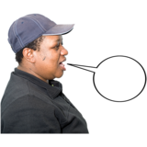 | - Do you have any other comments or suggestions?

