Please find enclosed content for you to use:

This includes:
- Text for website article
- Social media posts with campaign images to use.

Unlocking Wellbeing Event FOR SHARING (EMAIL / WEBSITE / NEWSLETTER, etc.)

Thanks for considering helping spread the word to encourage people to ‘taste’ and try wellbeing in so many ways, while we network and raise awareness, challenge stigma around mental health with our free event.

Here is the link to information about our event and the free signup:

https://bit.ly/UnlockingWellbeingFens

Here is the QR Code:



SOCIAL MEDIA POSTS

GUIDELINES
Please see below suggested copy for social media posts to promote the The SUN Network, Cambridgeshire Recovery Service (CRS) and The Ferry Project Unlocking Wellbeing Event 2023. Our poster are provided as a (PNG) image and PDF (clickable links embedded) versions as well as an animated poster with the words moving, and finally a short video clip where an attendee at a previous wellbeing event shares what they enjoyed of the event and why they recommend people come along.

Any questions or extra information about the toolkit - Please email: kc.cade@sunnetwork.org.uk

Handles: When promoting the campaign feel free to link the below handles
  - Twitter: @SUNNetworkCambs / @CambsRecovery
  - Facebook: @SUNNetworkCambs / @CambsRecovery
  - Instagram: @SUNNetworkCambs / @CambsRecovery

Message | Asset | Alt text
Facebook / LinkedIn / Instagram post:  You are invited to join our free wellbeing event on 5 October in Wisbech.  https://bit.ly/UnlockingWellbeingFens  Enjoy a beverage & chat on our ‘listening sofas’, try acupuncture or a 1-on-1 fitness session or massage therapy. Meet our special guests & hear the inspiring stories from people who have overcome tragedies & how they unlock their own wellbeing. Get hands-on doing art & have a health check. The star of the day, I expect, will be Erwin the therapy dog from People & Animals!  We are partnering with @CambsRecovery and #TheFerryProject to offer ‘tasters’, free ways to strengthen our health, enjoy ourselves and make new connections with others in the Wisbech area. | 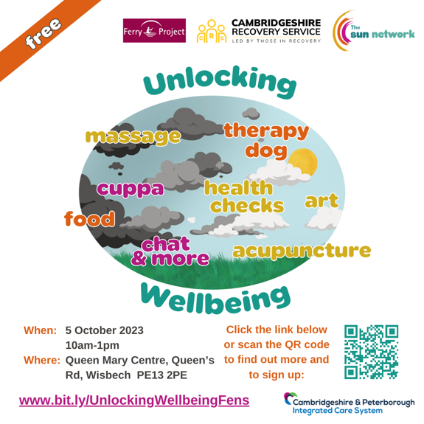 | An image promoting our Unlocking Wellbeing Event with date (5 Oct 2023) time (10am-1pm) location (Queen Mary Centre, Queen’s Rd, Wisbech PE13 2PE) and the link to sign up online with this website link:  https://bit.ly/UnlockingWellbeingFens  Various dark and grey and white clouds picture and what to expect at the event, like “cuppa”, “therapy dog”, “massage”, “acupuncture”, “snacks” “chat & more”
Twitter post :  You are invited to join our free wellbeing event on 5 October in Wisbech. https://bit.ly/UnlockingWellbeingFens… Enjoy a beverage & chat on our ‘listening sofas’, a health-check, try acupuncture, a 1-on-1 fitness session or massage therapy taster.  @cambsrecovery  #FerryProject  Enjoy a beverage & chat on our ‘listening sofas’, a health-check, try acupuncture, a 1-on-1 fitness session or massage therapy taster.  @cambsrecovery  #FerryProject | 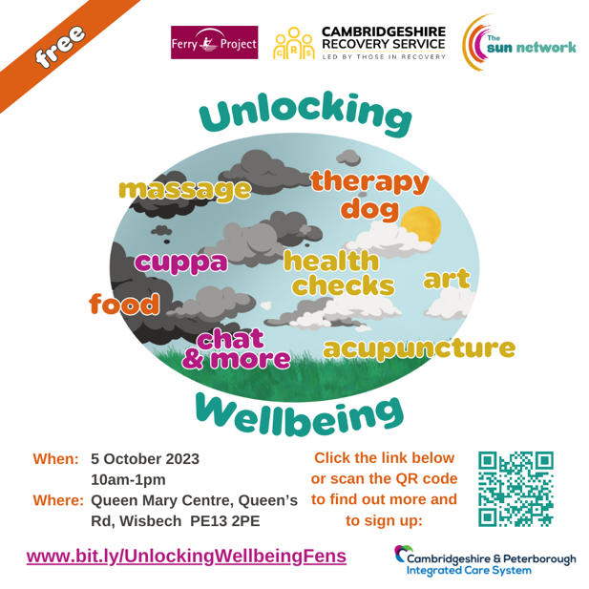 | An image promoting our Unlocking Wellbeing Event with date (5 Oct 2023) time (10am-1pm) location (Queen Mary Centre, Queen’s Rd, Wisbech PE13 2PE) and the link to sign up online with this website link:  https://bit.ly/UnlockingWellbeingFens  Various dark and grey and white clouds picture and what to expect at the event, like “cuppa”, “therapy dog”, “massage”, “acupuncture”, “snacks” “chat & more”

Any questions or extra information about the toolkit - Please email: kc.cade@sunnetwork.org.uk

